Collin Gamble
PRO390 – Capstone Project
Week 5: Controlled Attack Testing
Degree: Information Systems & Cybersecurity
Date: February 6, 2026

1. Introduction
The purpose of Week 5 was to perform controlled attack testing against the intentionally vulnerable version of the Capstone web application. The vulnerabilities tested during this phase were previously identified and documented in Week 4 and were introduced exclusively for educational purposes within a local lab environment.
The goal of this testing phase was to simulate realistic attacker behavior, validate exploit reliability, and collect clear evidence demonstrating the security impact of each vulnerability. Testing was conducted using Postman for API-level attacks and standard web browsers for client-side exploitation. All attacks were executed against localhost, no real user data was used, and the application was never exposed to the internet.
Screenshots referenced throughout this document correspond to evidence captured during testing and are identified by filename at the appropriate locations.

2. Attack Scenario 1: NoSQL Injection Authentication Bypass
Vulnerability Tested
NoSQL Injection – Authentication Bypass
OWASP Top 10 (2021): A03 – Injection
Tool Used
Postman
Attack Description
The authentication endpoint accepts user-supplied input that is passed directly into a MongoDB query without enforcing strict data type validation. Because MongoDB supports query operators such as $ne, an attacker can inject query logic instead of literal credential values, resulting in authentication bypass.
Attack Steps
- A POST request was sent to the vulnerable authentication endpoint.
- The request body contained MongoDB query operators instead of strings:
- {
- "username": { "$ne": null },
- "password": { "$ne": null }
- }
- The server processed the injected query and returned a successful authentication response.
- A valid session cookie (connect.sid) was issued.
- The session cookie was reused to access a protected route.
Result
Authentication was successfully bypassed without valid credentials, and protected application content was accessed.
Evidence Collected
Postman Post Login page.jpg
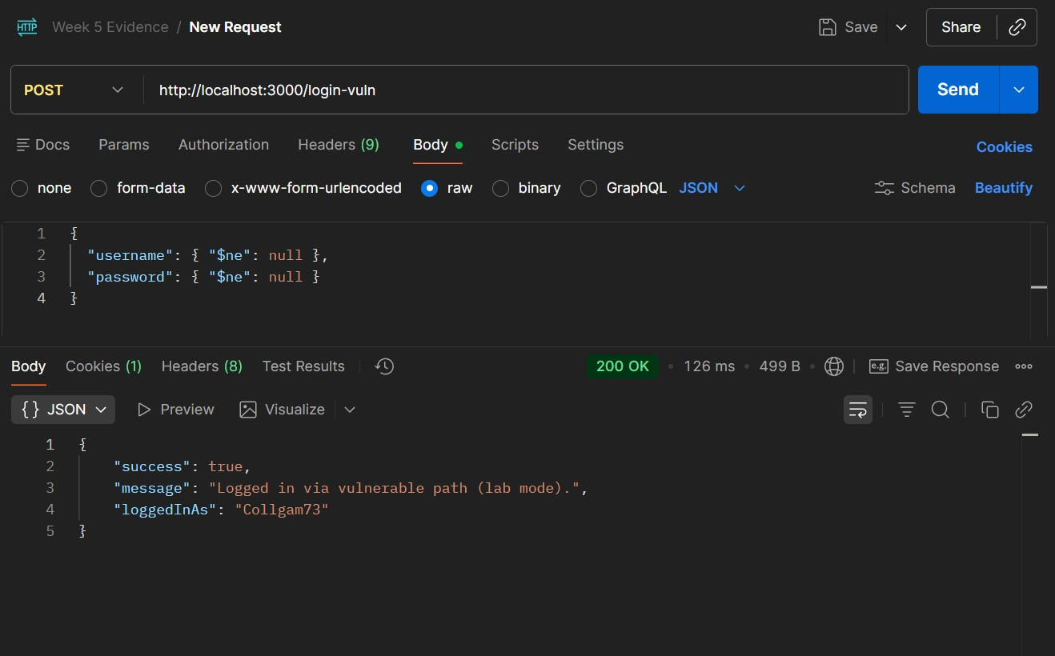
Postman Cookies.jpg
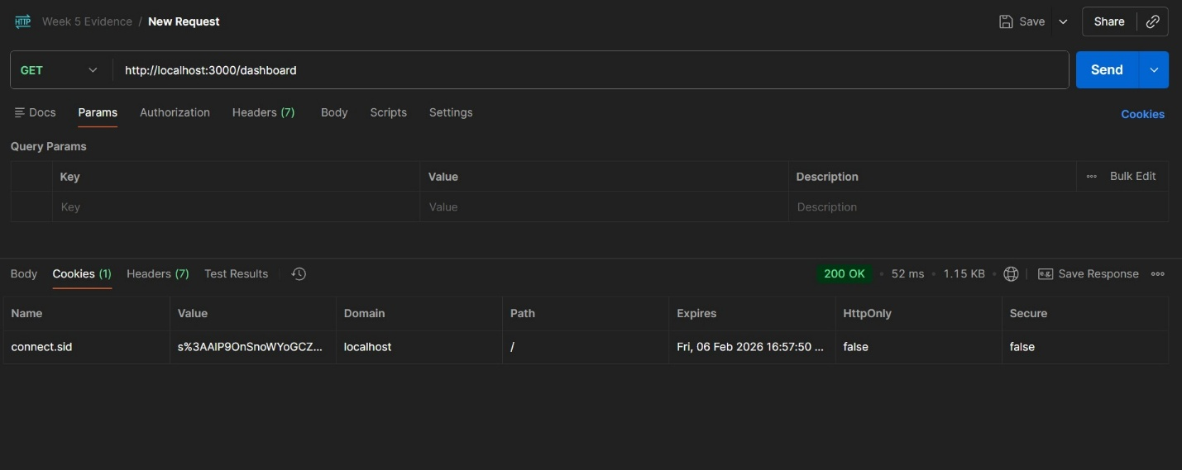
Postman Get Dashboard Request.jpg
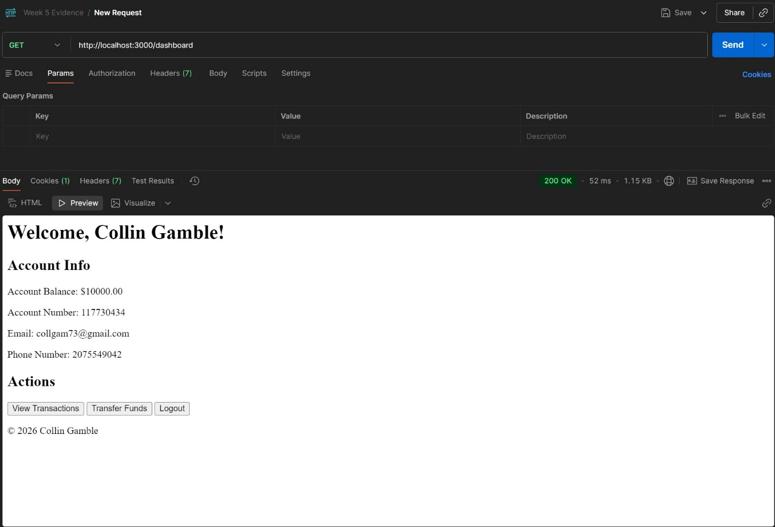
These screenshots demonstrate the injected request payload, the issuance of a valid session cookie, and access to the protected dashboard.

3. Attack Scenario 2: Stored Cross-Site Scripting (XSS)
Vulnerability Tested
Stored XSS (Persistent Client-Side Injection)
OWASP Top 10 (2021): A03 – Injection
Tool Used
Web Browser
Attack Description
The application allows users to submit a memo when transferring funds. This memo is stored in the database and later rendered on the transactions page without proper output encoding. Because the application renders this content as raw HTML, injected JavaScript executes when the page is viewed.
Attack Steps
- Logged into the application as a normal user.
- Navigated to the Transfer Funds page.
- Entered the following payload into the memo field:
- <img src=x onerror="alert('Stored XSS')">
- Completed the transfer.
- Navigated to the transactions page.
Result
The JavaScript payload executed automatically when the transactions page loaded. The payload persisted in the database and executed each time the page was viewed.
Evidence Collected
Website Showed Memo XSS.jpg
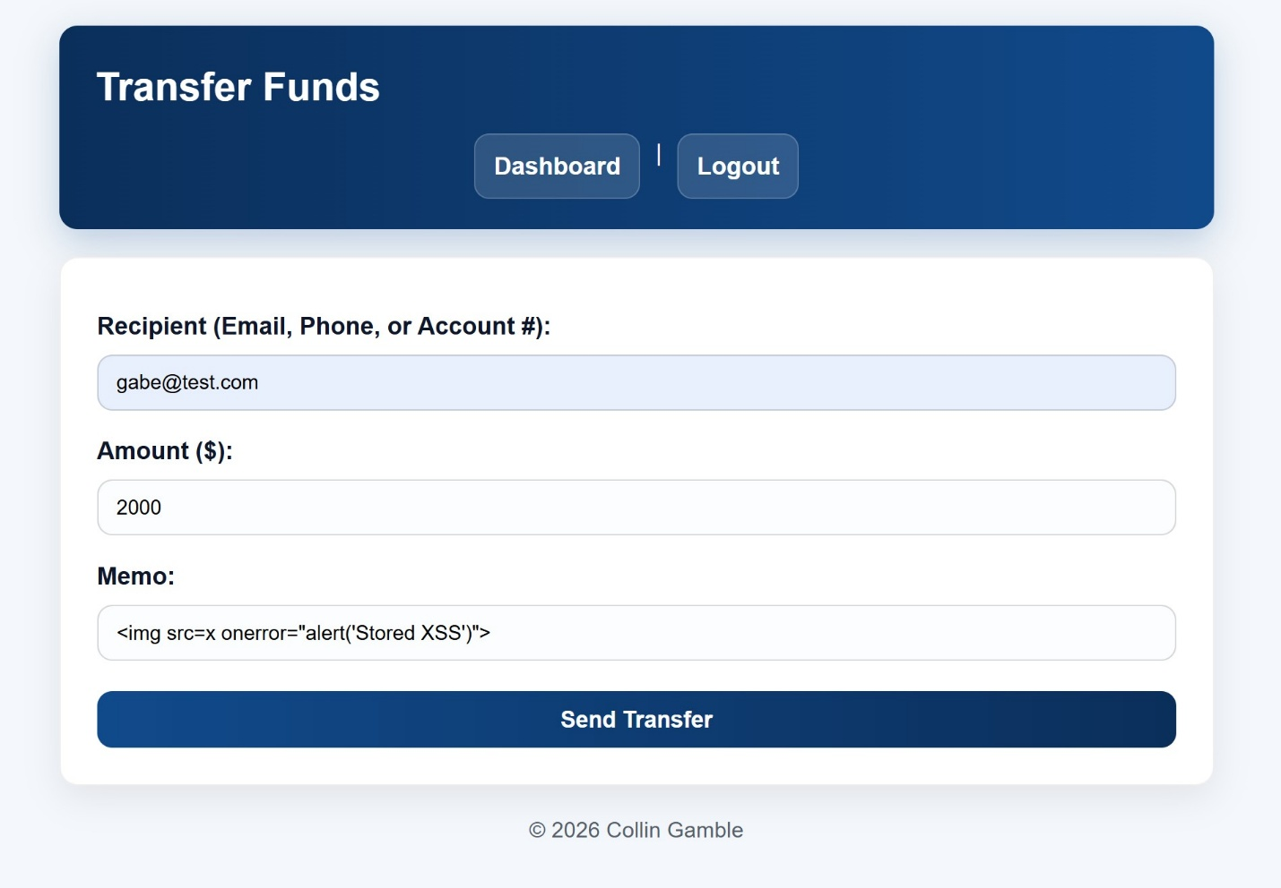
Website XSS Alert on Transactions Page.jpg
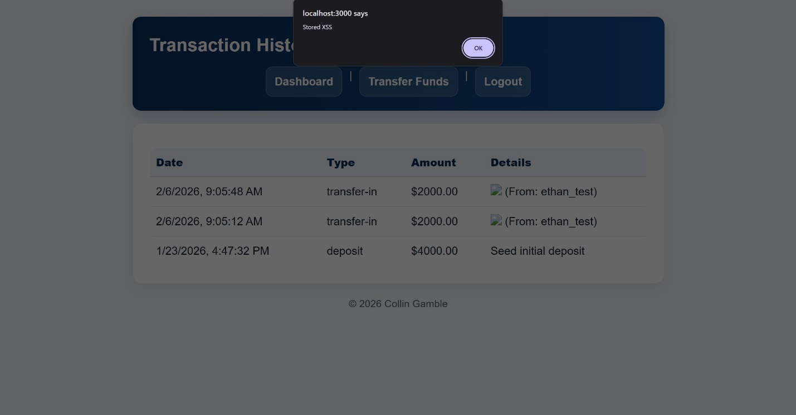
These screenshots show the malicious payload stored in the transaction memo and the resulting JavaScript execution.
4. Attack Scenario 3: Account Enumeration
Vulnerability Tested
Account Enumeration via Verbose Error Messages
OWASP Top 10 (2021): A07 – Identification & Authentication Failures
Tool Used
Web Browser
Attack Description
The application returns different error messages depending on authentication failure conditions. These differences allow attackers to infer whether usernames exist and whether specific email addresses are associated with accounts.
Login Enumeration Steps
- Submitted a login attempt using a nonexistent username.
- The application returned an error indicating the username was not found.
- Submitted a login attempt using a valid username and an incorrect password.
- The application returned a different error message.
Forgot Password Enumeration Steps
- Submitted a nonexistent username with any email address.
- Submitted a valid username with an incorrect email address.
- Submitted a valid username with the correct email address.
Result
Distinct responses allowed attackers to reliably confirm valid usernames and determine whether specific email addresses were associated with those accounts.
Evidence Collected

Website Username not found error.jpg
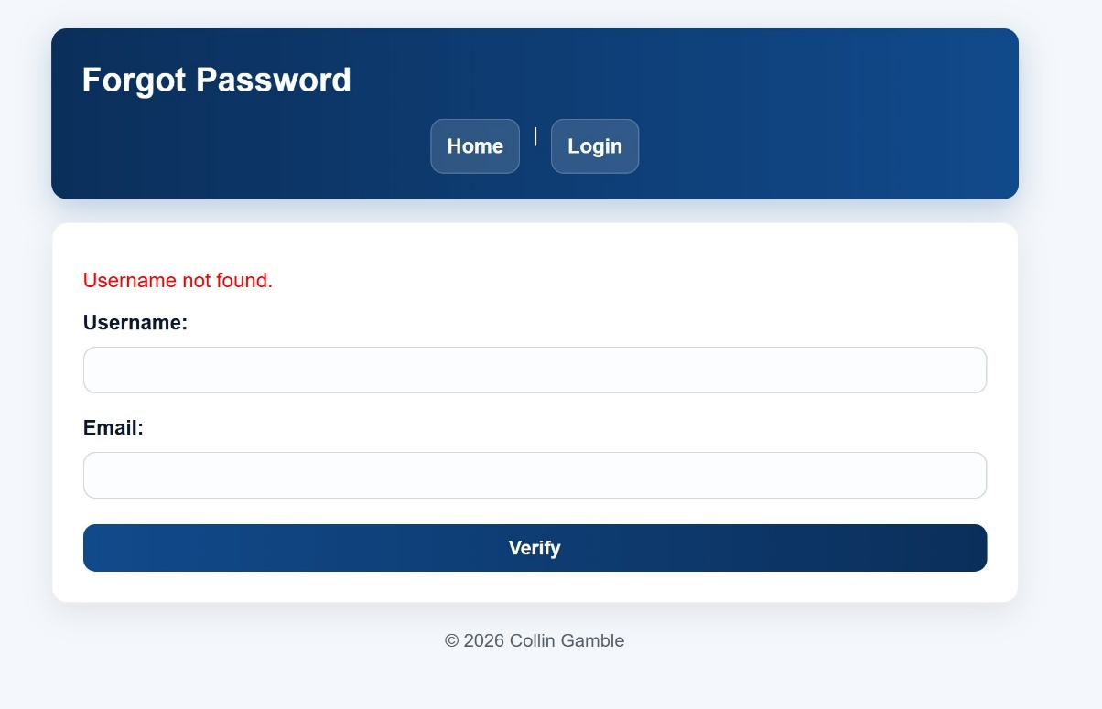
Website Wrong password error.jpg
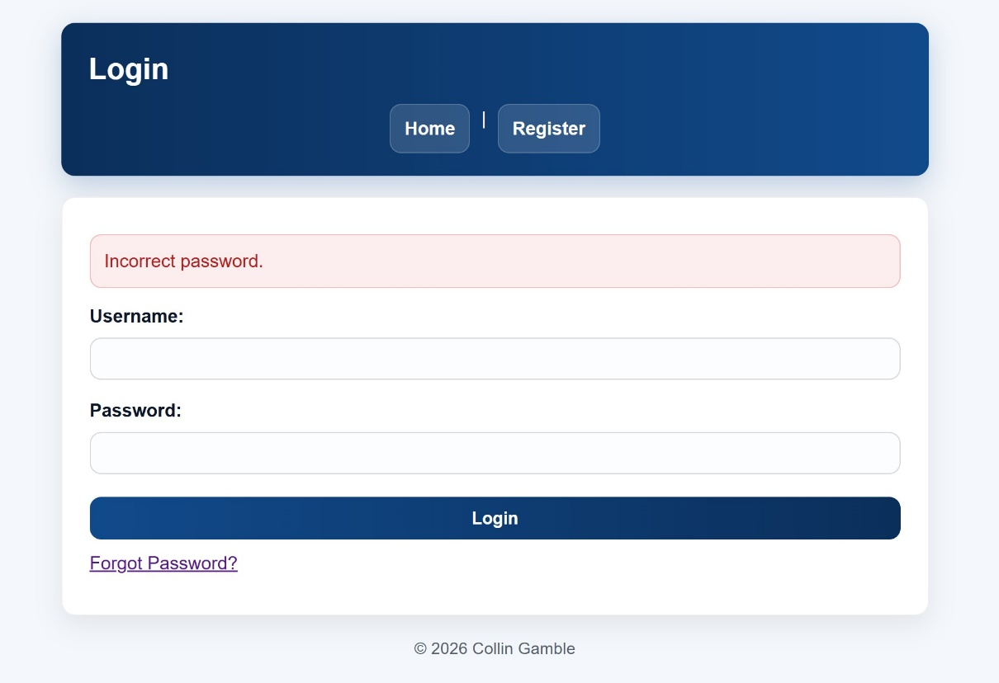

Website User not found error.jpg
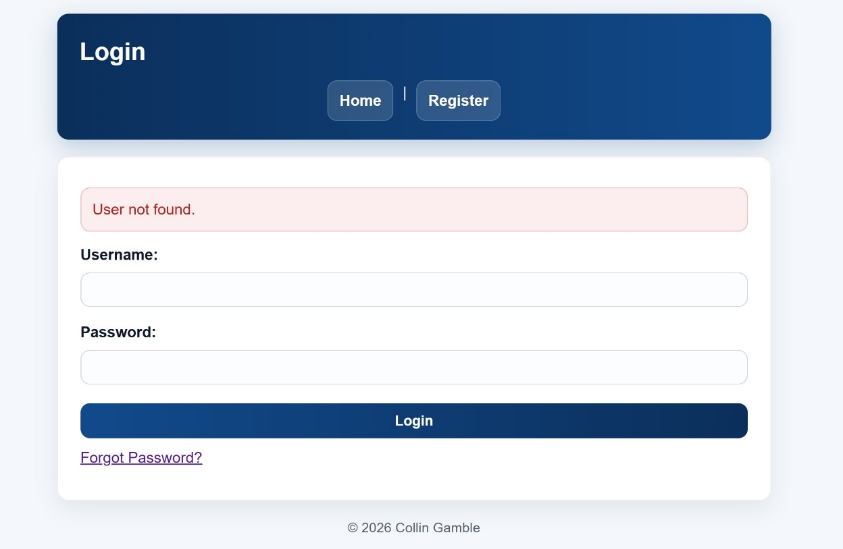
Website Email does not match username error.jpg
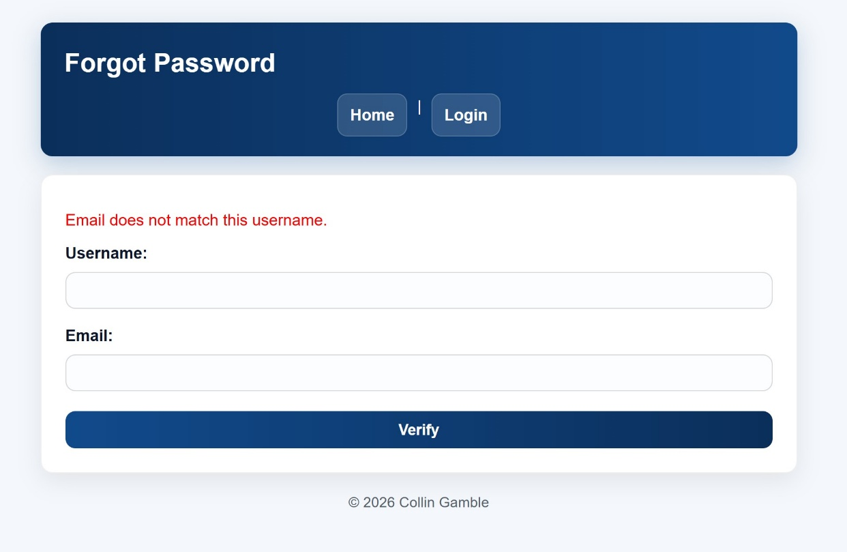
These screenshots demonstrate how authentication-related responses vary based on internal account state.
5. Attack Scenario 4: Chained Attack (Stored XSS + Session Cookie Exposure)
Vulnerabilities Tested
• Stored XSS
• Insecure Session Cookie Configuration
OWASP Top 10 (2021): A05 – Security Misconfiguration
Attack Description
When the application runs in lab mode, the HttpOnly flag is disabled for session cookies. This allows client-side JavaScript to access the session identifier. By chaining this misconfiguration with stored XSS, an attacker can read session cookies from a victim’s browser.
Attack Steps
- A stored XSS payload executed on the transactions page.
- JavaScript accessed document.cookie.
- The session cookie (connect.sid) was exposed to client-side code.
Result
The session identifier was accessible via JavaScript, demonstrating how stored XSS can be chained with insecure session configuration to enable session hijacking.
Evidence Collected
Postman Cookies.jpg


Capstone Website Cookies connectsid after.jpg
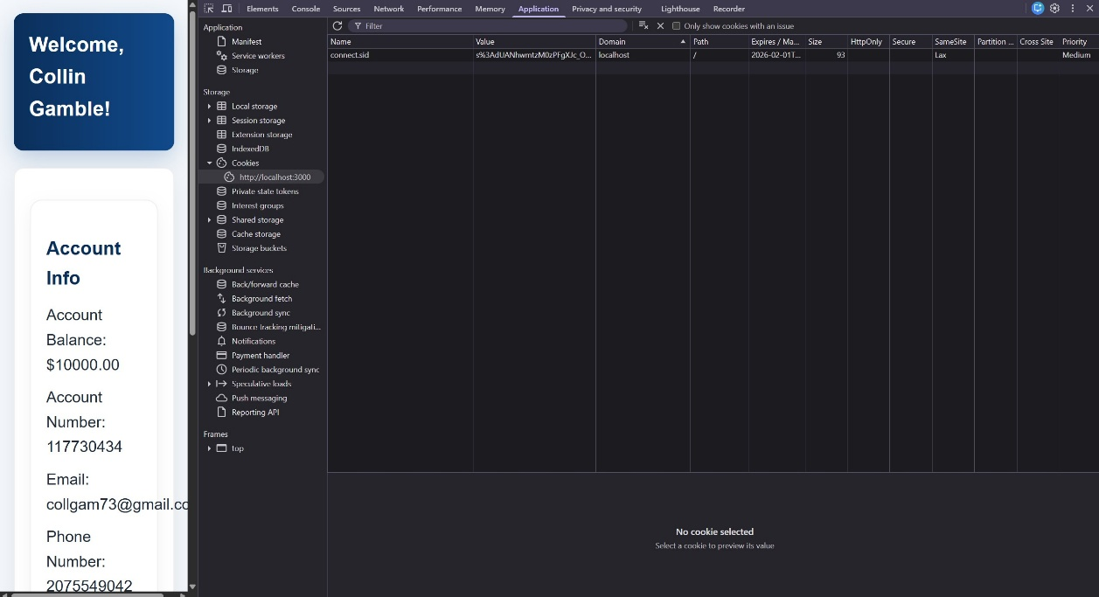
These screenshots confirm that the session cookie lacked the HttpOnly flag and was accessible to JavaScript.

6. Summary of Attack Outcomes
The controlled attack testing phase demonstrated that the intentionally introduced vulnerabilities were exploitable and had meaningful security impact. Authentication could be bypassed, persistent client-side code execution was achieved, account information could be enumerated, and session security could be weakened through misconfiguration. These findings establish a clear baseline for the remediation phase, during which mitigations will be applied and re-tested to demonstrate improved security posture.

AI Assistance Disclosure
Portions of this document, including organization, formatting, and refinement of written explanations, were drafted and edited with the assistance of AI (ChatGPT). All vulnerability implementation, testing, exploitation, evidence collection, and analysis were performed by the student.

